System analysis   
Instagram mobile application   
Prepared by Kim Tamila

**Table of Contents**

**Introduction**

Purpose

Project Scope

**Overall Description**

2.1 Product Perspective

2.2 Product Features

2.2.1 User Registration and Authentication

2.2.2 Photo Upload and Management

2.2.3 Follow/Unfollow

2.2.4 Like/Unlike

2.2.5 Comment

2.2.6 News Feed

2.2.7 Stories Functionality

2.2.8 Reels Functionality

2.3 User Classes and Characteristics

2.4 Operating Environment

2.5 Design and Implementation Constraints

**System Features**

3.1 User Registration and Authentication

3.1.1 Description and Priority

3.1.2 Stimulus/Response Sequences

3.1.3 Functional Requirements

3.2 Photo Upload and Management

3.2.1 Description and Priority

3.2.2 Stimulus/Response Sequences

3.2.3 Functional Requirements

3.3 Follow/Unfollow

3.3.1 Description and Priority

3.3.2 Stimulus/Response Sequences

3.3.3 Functional Requirements

3.4 Like/Unlike

3.4.1 Description and Priority

3.4.2 Stimulus/Response Sequences

3.4.3 Functional Requirements

3.5 Comment

3.5.1 Description and Priority

3.5.2 Stimulus/Response Sequences

3.5.3 Functional Requirements

3.6 News Feed

3.6.1 Description and Priority

3.6.2 Stimulus/Response Sequences

3.6.3 Functional Requirements

3.7 Stories Functionality

3.7.1 Description and Priority

3.7.2 Stimulus/Response Sequences

3.7.3 Functional Requirements

3.8 Reels Functionality

3.8.1 Description and Priority

3.8.2 Stimulus/Response Sequences

3.8.3 Functional Requirements

**External Interface Requirements**

4.1 User Interfaces

4.2 Hardware Interfaces

4.3 Software Interfaces

4.4 Communications Interfaces

**Nonfunctional Requirements**

5.1 Performance Requirements

5.2 Safety Requirements

5.3 Security Requirements

5.4 Software Quality Attributes

**Other Requirements**

6.1 Reporting System

6.2 Data Export Functionality

**Appendices** A: Glossary B: Analysis Models

**Project: Instagram-like Application  
1. Introduction  
1.1 Purpose**

Or build an app just like Instagram that let's people share photos with their friends.

**1.2 Project Scope**

Description: The app's profile management function lets users create and modify their own unique profiles.  
Benefits: User Personalization, Identity Expression  
Goals: Make it easy for users to change and update their pictures. Users can fill in and edit their bios, including any personal information that is relevant.

**2.1 Product Perspective**

As one of the social-media services under the Facebook product family. In October 2010, developed by Kevin Systrom and Mike Krieger, Instagram was released. Instagram is a stand-alone product with its own features and capabilities. Instagram, as a platform that emphasizes visual content is very much image oriented. By providing a place for users to engage with friends and family, as well available influencers and brands through visual storytelling the product is top of its class.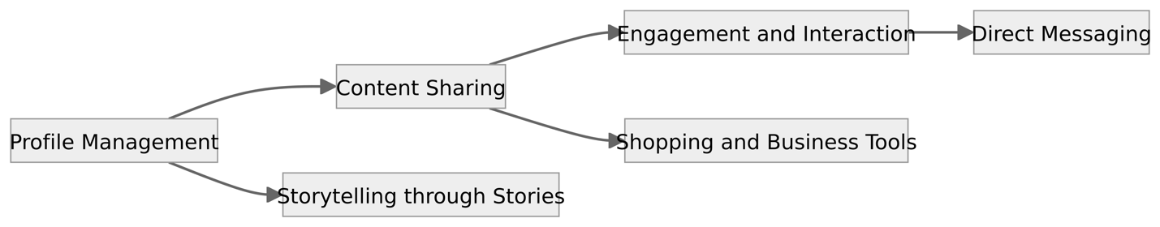

**2.2 Product Features**

Profile Management: It allows users to write their own profile, upload a picture and set privacy levels.  
Content Sharing: People on Instagram can share photos, videos and tag locations.  
Storytelling through Stories:Instagram Stories enable users to create and post such ephemeral content that contributes their own chapter in the story of their experience.  
Engagement and Interaction: There are likes, comments and direct messages through which users can interact with one another on Instagram.  
Direct Messaging:Private conversations can be held by direct message exchanging text, photos and videos.  
Shopping and Business Tools:Instagram has launched a set of business and creator tools, including shopping features.

**2.3 User Classes and Characteristics**

Regular Users:  
Frequency of Use: Users who use it daily or almost every day for personal social interaction and content consumption.

Product Functions: It has a variety of functions: posting content, commenting on friends 'posts and exploring things.

Influencers:  
Frequency of Use: Prolific creators who are frequent users of the site, possibly as a source of income.  
Product Functions: Put an emphasis on content creation, analytics tracking and interacting with followers.

Business Accounts:  
Frequency of Use: Frequent use for brand promotion and dialogue with customers.  
Product Functions: Business Tools: Utilize analytics, shopping features and sponsored posts.

* **2.4 Operating Environment**

For the most part, Instagram is designed to be used on mobile devices such as smartphones and tablets.developed to be compatible with both iOS and Android operating systems. On desktop platforms, web browsers offer only limited functionality with Instagram. Take advantage of device-specific camera capabilities for capturing and sending photos, videos.

**2. 5 Design and Implementation Constraints**

Designers must take account of all kinds of mobile phone specifications, screen sizes and hardware capabilities in order to give users a consistent experience.  
To help the application keep pace with changing user needs and technological landscapes, Technological advancements is one of industry standards.

**3. System Features**

**3. 1 User Registration and Authentication**

**3.1.1 Description and Priority:**

• Description: This feature allows users to share multimedia content, like photos and videos, with their follower.  
• Priority: High priority. Because content sharing is the essential part of user involvement on the platform.

**3.1.2 Stimulus/Response Sequences:**

• Stimulus: User chooses the Share button on a post.  
• Response: The system asks the user to provide a caption, tags and specify visibility preferences. Then it is confirmed, and that content is shared out into followers' feeds.

**3.1.3 Functional Requirements:**

REQ-1: Media Capture and Selection:  
• Using the camera that is built into the device, users should be able to capture photos and videos or choose media from their phone's gallery.

REQ-2: Caption and Tagging:  
• Allow users to add captions and tags for their shared content in a text input field.

REQ-3: Visibility Settings:  
• Shared content should be visible to five levels: Public, Private; Followers Only.

REQ-4: Error Handling:  
• For example, the system must inform users when network connectivity is poor or other errors occur during upload. It should also instruct them on what to do next.

**4. External Interface Requirements**

**4.1 User Interfaces**

The user interface of the Instagram application is designed to provide an intuitive and aesthetically pleasing experience for users. Make sure that logos, colors, typography and other elements of the visual brand are consistent across interfaces. Use standard navigation patterns to help users move easily around different areas within an application. Both mobile and web interfaces should be responsive to screen sizes and resolutions.  
*• Accessibility; Security Alerts; Help and Tips; Notification Center: Settings.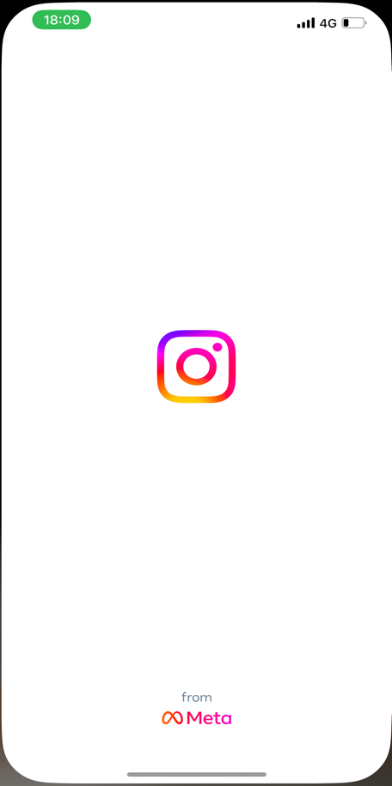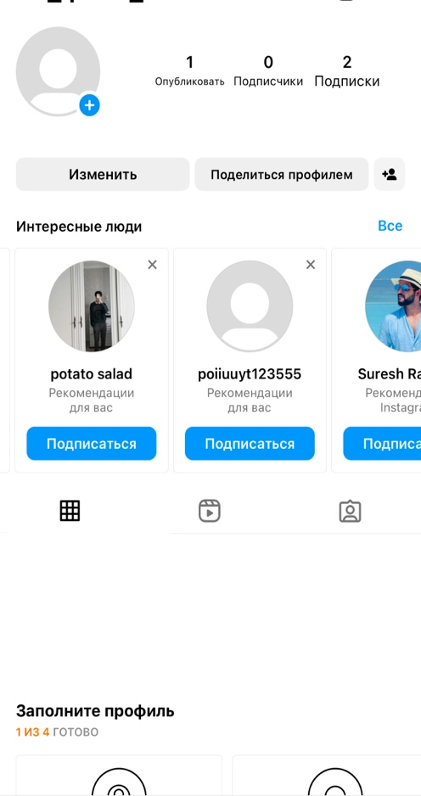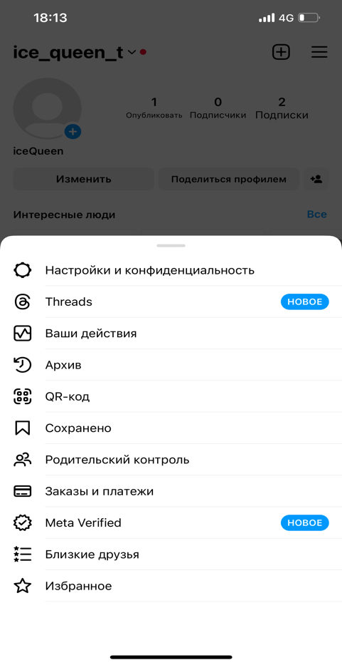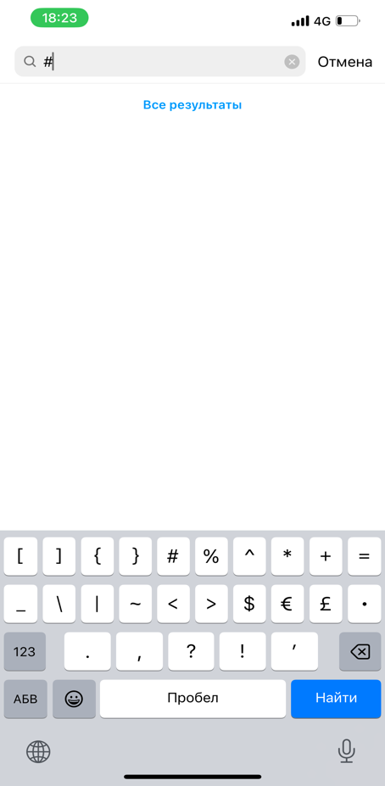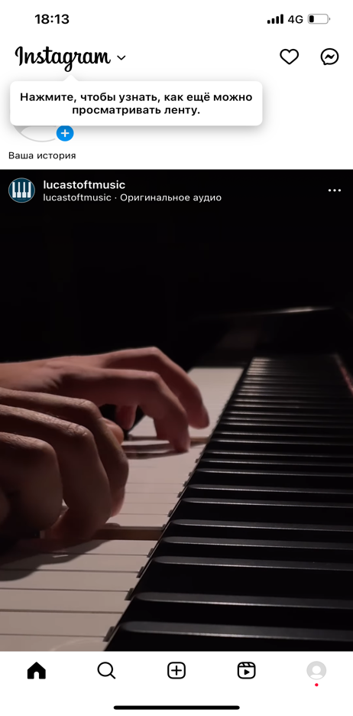*

**4. 2 Hardware Interfaces**  
• For example, the Instagram app works on iOS and Android-based handsets as well. For functions such as camera usage and storage management, with device hardware.  
• uses touchscreen control, buttons and gestures for user input and navigation.  
  
**4.3 Software Interfaces**  
Database System: For data storage, Instagram interacts with a relational database management system (RDBMS), such as MySQL or PostgreSQL.  
Data Items In: Social media user profiles, posts and comments, likes, etc.  
Data Items Out: Retrieval of user-dependent content, follower lists and engagement metrics.  
Purpose: Store and retrieve user-generated content as well as social interaction information efficiently.  
  
**4.4 Communications Interfaces**  
Notifications of account-related activities, such as resetting the password or verifying an email address.Sends notifications using standard email protocols, such as SMTP. protects sensitive email content through encryption (e.g., TLS) for message transmission. E-mail communications are not instantaneous. The speed of data transmission depends on the performance level of your email server.

**5. Nonfunctional Requirements**  
  
**5.1 Performance Requirements:**

• Real-time Content Delivery:  
• Requirement: The system must provide within 3 seconds of occurrence, real-time content updates like notifications and feed refresh.  
• Rationale: Dynamic, user-friendly and responsive.

**5.2 Safety Requirements:**

• Data Integrity and Redundancy:  
• Requirement: Back up data and maintain its integrity, to prevent loss or corruption of user-generated content.  
• Safeguards: Automated back up procedures, redundant storage solutions.  
• Prevention: Employ checks and error handling routines to ensure against data corruption.

**5.3 Security Requirements:**

multi-factor authentication for user login. With biometric identification and one-time passcodes, you can create a secure method of identifying users.

**5.4 Software Quality Attributes:**

• Usability:  
• Requirement: The user interface should be easy to understand.  
• Maintainability:  
• Requirement: Codebase will respect coding standards, and routine code reviews should be conducted at least once a month.  
• Code Documentation: One must also keep complete code documentation for ease of maintenance.  
• Reliability:  
• Requirement: Reach a system uptime of at least 99.5 %.  
• Monitoring: Also deploy real-time monitoring of system performance and error trackin

**6. Other Requirements:**

The database should support concurrent connections from at least 10,000 users without degradation in performance. The application should support at least 20 languages for global accessibility.

**Appendix A: Glossary:**

Acronyms:

HTTPS: Hypertext Transfer Protocol Secure

API: Application Programming Interface

RDBMS: Relational Database Management System

**Appendix B: Analysis Models:**

